Q1: If you have 10 filters that are 3x3x3 in one layer of a convolutional neural network, how many parameters does that layer have?
Ans: Each filter will has 27 + 1 (bias) = 28 parameters. Since this layer has 10 filter so total # of parameters is 28*10=280.

Q2:
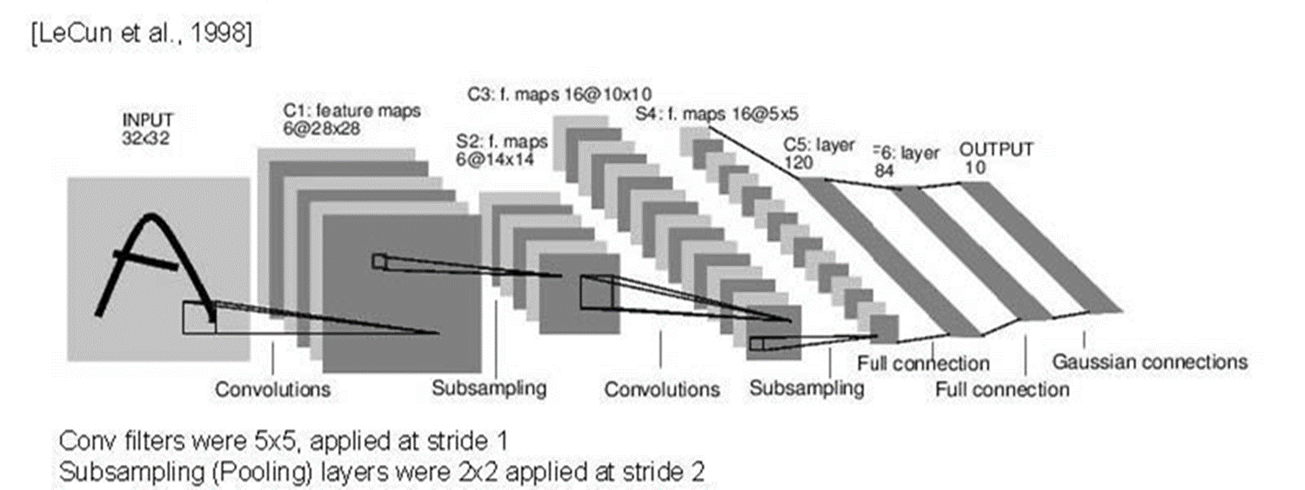

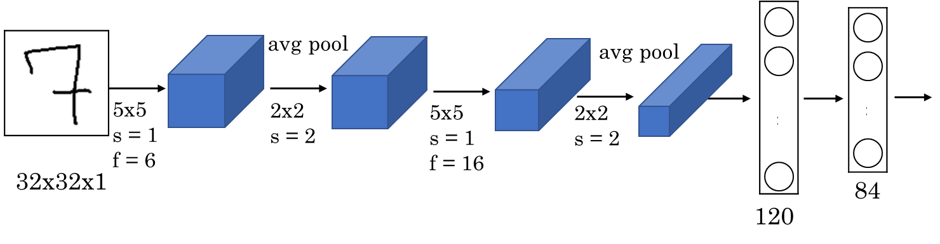

Layer |  |  |  |  | Output Volume | Total Parameters  (with bias) | Total Parameters  (without bias)
Name | # of Filters | Filter size | Stride | Padding
Input | NA |  |  |  | 32x32x1 | NA | NA
Conv1 | 6 | 5x5x1 | 1 | 0 | 28x28x6 | (5x5x1+1)x6 | (5x5x1)x6=150
Pool1 | NA | 2x2 | 2 | 0 | 14x14x6 | 0 | 0
Conv2 | 16 | 5x5x6 | 1 | 0 | 10x10x16 | (5x5x6+1)x16
Pool2 | NA | 2x2 | 2 | 0 | 5x5x16 | 0 | 0
FC3 | NA | NA | NA | NA | 120 | 48120 | 48000
FC4 | NA | NA | NA | NA | 84 | (120x84)+84 | 120x84

Q3:
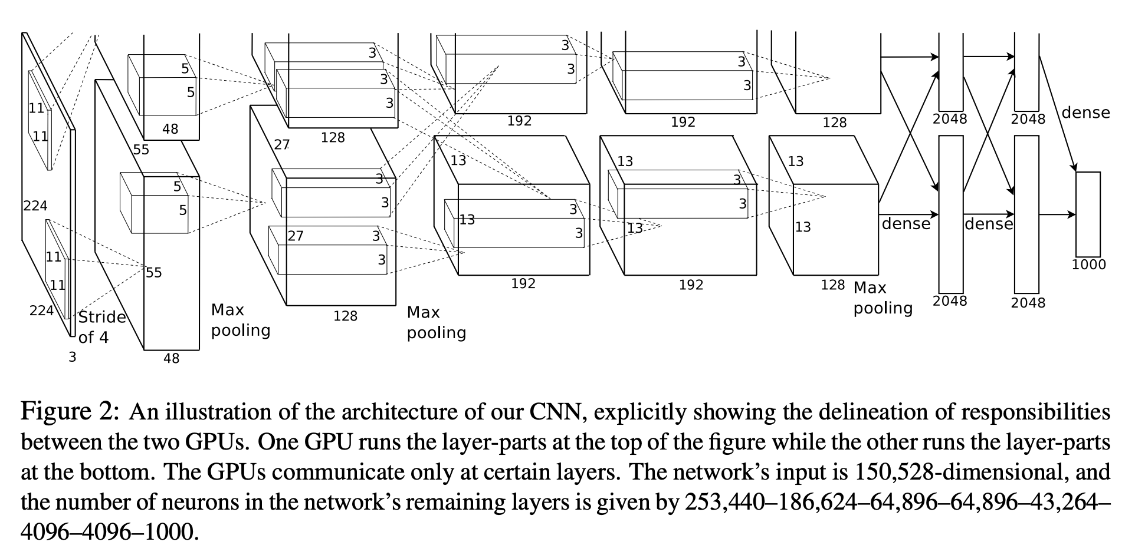

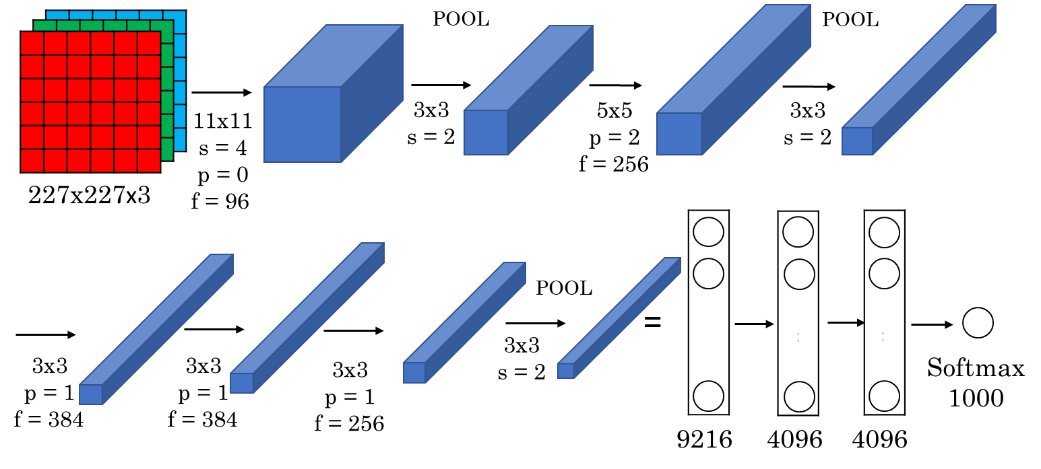

AlexNet Network - Structural Details
Input | Output | Layer | Stride | Pad | Kernel size | In | Out | # of Parameters
227x227x3 | 55x55x96 | Conv1 | 4 | 0 | 11x11x3
55x55x96 | 27x27x96 | Maxpool1 | 2 | 0 | 3x3
27x27x96 | 27x27x256 | Conv2 | 1 | 2 | 5x5x96
27x27x256 | 13x13x256 | Maxpool2 | 2 | 0 | 3x3
13x13x256 | 13x13x384 | Conv3 | 1 | 1 | 3x3x256
13x13x384 | 13x13x384 | Conv4 | 1 | 1 | 3x3x384
13x13x384 | 13x13x256 | Conv5 | 1 | 1 | 3x3x384
13x13x256 | 6x6x256 | Maxpool5 | 2 | 0 | 3x3
NA |  | FC6
 |  | FC7
 |  | FC8
*In and Out are # of channels in input and output images or feature maps.

Q4: Max Pooling: Find the hyperparameters (filter size and stride).

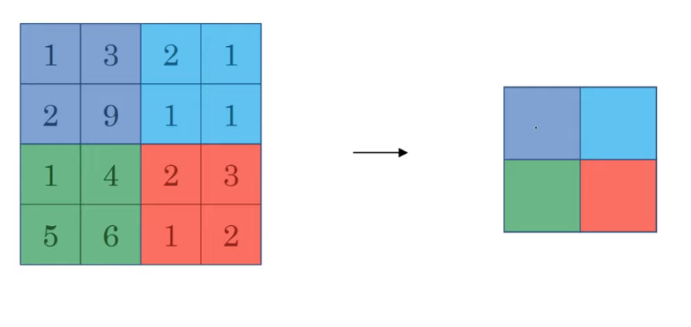
Filter size = 2x2
Stride = 2

